ACT REGISTRATION GUIDE 19-20
To Register:
- Go to actstudent.org
- If you have never registered yourself, create a new account.
- You may link your test scores from March to your account by entering the ACT ID found on the top of your score report. _______________________________ *Skip this step if you do not have the ACT ID.
- Completely answer all sections.
- For the section about “Your High School” (Section L), please enter the AHS high school code – 191905
- We have approximately 244 Seniors and 217 Juniors this year. Use the chart below to estimate your rank. We do not provide rank information until graduation.
Rank Estimate Basic GPA (4.0 Scale)
TopQuarter (0-25%) 3.5- 4.0
Top Half (25 – 50%) 3.0-3.49
Third Quarter (50- 75%) 2.5-2.9
Bottom Quarter (75-99%) 2.4 and below
- Don’t forget to send your score reports to:
- ** TOPS (LOSFA) - Code 1595 - YOU MUST CHOOSE THIS IN ORDER FOR TOPS TO BE PROCESSED
- Your top 3 college or military options
- NCAA- Code 9999 if you are planning to participate in collegiate sports.
- Choose your test date and center. You do not have to take the test at AHS, but if you choose to you should use TEST CENTER CODE 166580.
- Pay using a credit card or fee waiver. The cost of the basic test is now $50. To qualify for a fee waiver you should be in 11th or 12th grade and have a code indicating that you receive free or reduced lunch.
- Free ACT Prep is available through many sources such as ACT Academy, March2success.com, and ACT Student on Facebook.
- Premium ACT prep is available through Kaplan. You may purchase subscriptions while registering for a test. If you have a fee waiver, you can register for FREE!
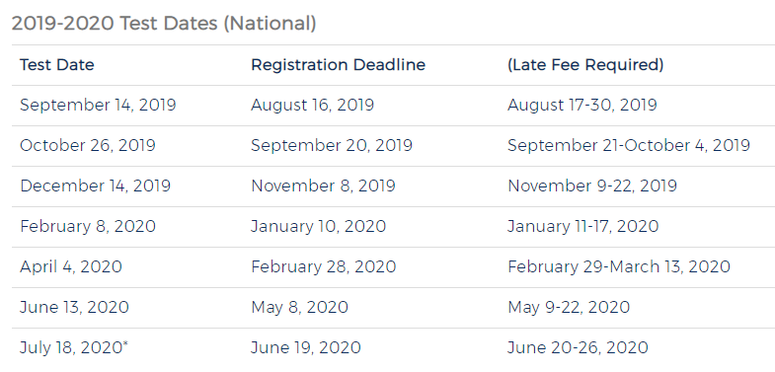
**April 4th is the last test to use for full TOPS Eligibility.

